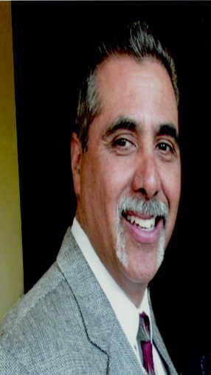 | JESSE ROMERO  Jesse is a full-time bilingual Catholic Lay Evangelist, who is nationally acclaimed for his dynamic, upbeat Christ centered preaching. His preaching apostolate is "On Fire Evangelization."  Jesse is a resident of Arizona and a retired Los Angeles Deputy Sheriff who has been married to his wife Anita since 1983, and is parent of three children and grandchildren
He has a B.A. from Mount St Mary’s University in Los Angeles and an M.A. in Catholic Theology from Franciscan University in Steubenville, Ohio. He is a bilingual Catholic author. (1) Recipient of the Archbishop Fulton J. Sheen Award, (2) The Fullness of Truth “Defender of Faith” Award & (3) “Sports Faith International Award”
Jesse has been on Catholic radio for over 15 years now hosting teaching and speaking in English & Spanish. Currently on virginmostpowerfulradio.org hosting “The Terry and Jesse Show,” & “Jesus 911.” Jesse is also a host on a spanish network show Enfamilia Radio” in Phoenix, Arizona.
He speaks on all things Catholic such as:
- Catholic Evangelization
- Apologetics
- Marriage & Family
- Male Spirituality
- Spiritual Warfare
- Culture Wars
- Teen & Chastity talks
Jesse has been preaching since 1995. He has also defended Holy Mother Church in several official debates with different Protestant Pastors, and on Spanish television against secular humanist.

Jesse’s motto is: Love God, Save Souls, & Slay Error!

